NAME:Rishik JK
REG.NO :192511052

CSA1702-ARTIFICIAL INTELLIGENCE
LAB EXPERIMENT

20. Prolog Program for Planets Database

1. Aim
To write a Prolog program to create a database of planets and retrieve information about them.

2. Algorithm
- Start the program
- Create a database containing planet names and their order from the Sun.
- Define a rule to retrieve planet information.
- Give the planet name as input.
- Display the corresponding position.
- Stop the program.

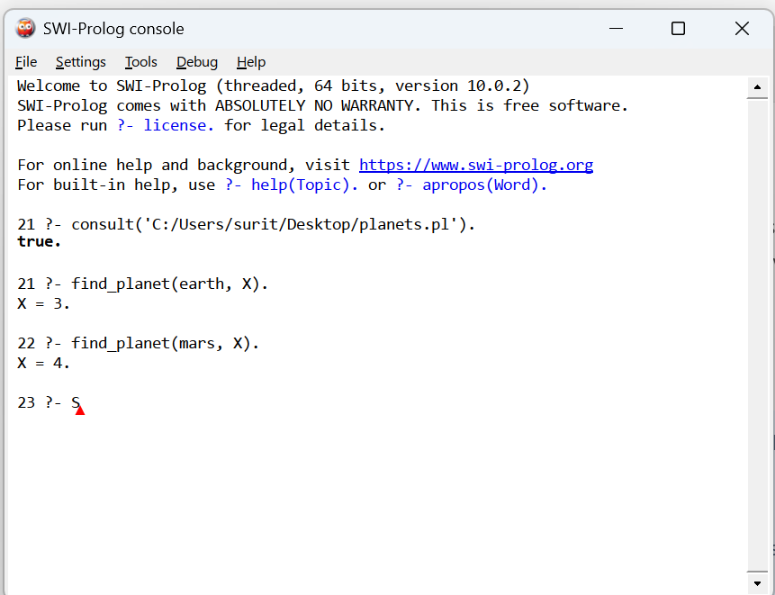

Result
Thus, the Prolog program to create a database of planets and their positions from the Sun was successfully implemented and executed. The position of the given planet was retrieved successfully.

